**WEEK – 2 : JUNIT_BASIC TESTING EXERCISES**

**EXERCISE 1: SETTING UP JUNIT**

**Main Class: Calculator.java**

package com.example;

public class Calculator {

public int add(int a, int b) {

return a + b;

}

}

**Test Class: CalculatorTest.java**

package com.example;

import static org.junit.Assert.*;

import org.junit.Test;

public class CalculatorTest {

*@Test*

public void testAdd() {

Calculator calc = new Calculator();

int result = calc.add(5, 3);

*assertEquals*(8, result);

}

}

**OUTPUT**

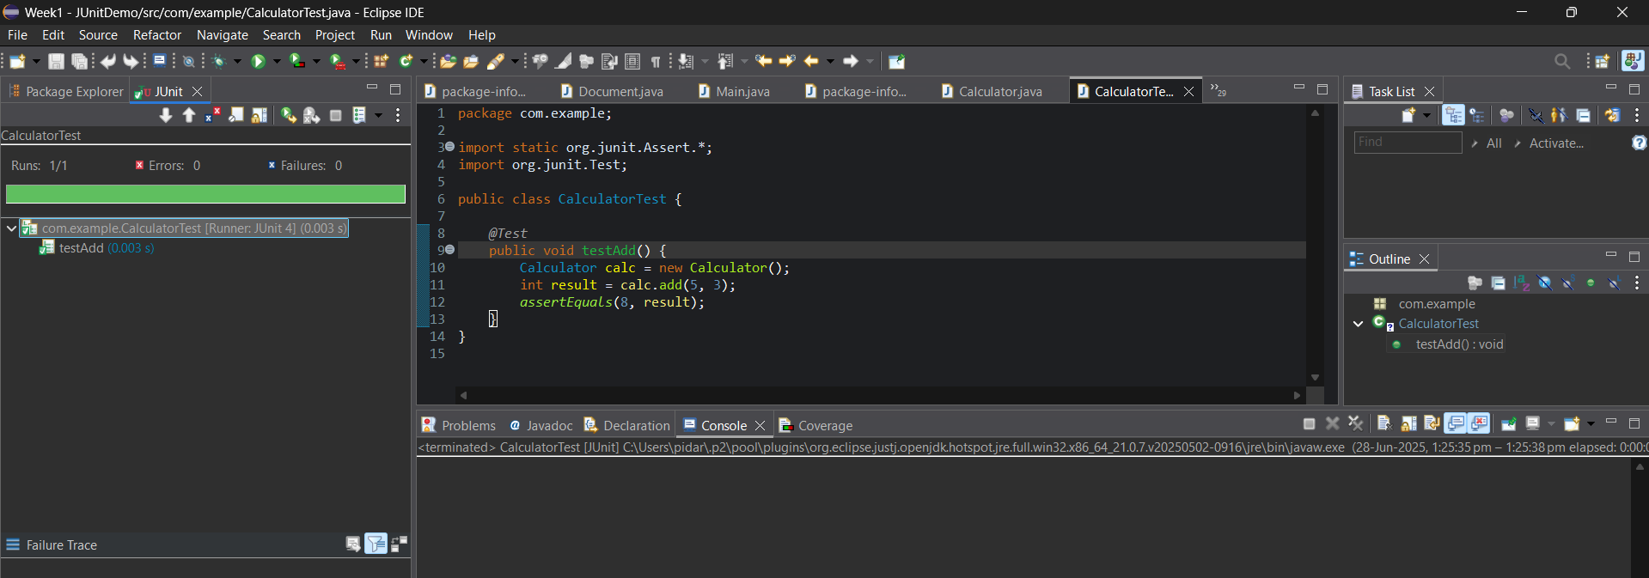

**EXERCISE 3: ASSERTIONS IN JUNIT**

**AssertionsTest.java**

package com.example;

import static org.junit.Assert.*;

import org.junit.Test;

public class AssertionsTest {

*@Test*

public void testAssertions() {

*assertEquals*(5, 2 + 3);

*assertTrue*(5 > 3);

*assertFalse*(5 < 3);

*assertNull*(null);

*assertNotNull*(new Object());

}

}

**OUTPUT**

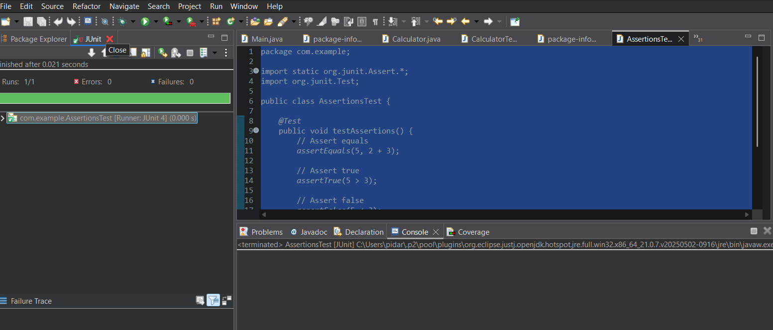

**EXERCISE 4: ARRANGE-ACT-ASSERT (AAA) PATTERN WITH SETUP AND TEARDOWN** **IN** **JUNIT**

**Calculator.Java**

package com.example;

public class Calculator {

public int add(int a, int b) {

return a + b;

}

public int subtract(int a, int b) {

return a - b;

}

}

**CalculatorTest.Java**

package com.example;

import static org.junit.Assert.*;

import org.junit.Before;

import org.junit.After;

import org.junit.Test;

public class CalculatorTest {

private Calculator calculator;

*@Before*

public void setUp() {

calculator = new Calculator();

System.***out***.println("🔧 Setup: Calculator initialized");

}

*@After*

public void tearDown() {

calculator = null;

System.***out***.println("🧹 Teardown: Calculator cleaned up");

}

*@Test*

public void testAdd() {

int a = 5, b = 3;

int result = calculator.add(a, b);

*assertEquals*(8, result);

}

public void testSubtract() {

int a = 10, b = 4;

int result = calculator.subtract(a, b);

*assertEquals*(6, result);

}

}

**OUTPUT**

